ECE 5367: Project 4 – Whitney Tran and Megan Lehmann

Link to Video: https://youtu.be/WMlj-kDMpKs

List of assumptions:

* The picture of the card must have a plain dark background.
* There can be no shadow covering the card. There should be uniform illumination, with no glare on the card.
* The picture is of a playing card of the common format (Bicycle).
* The entire card must be in frame.
* The user of the script has corrected the file paths to the templates (lines 21-24 and 60-62) to match where they saved them.
* The camera must be parallel to the card when the image is taken.

Algorithm Pipeline:

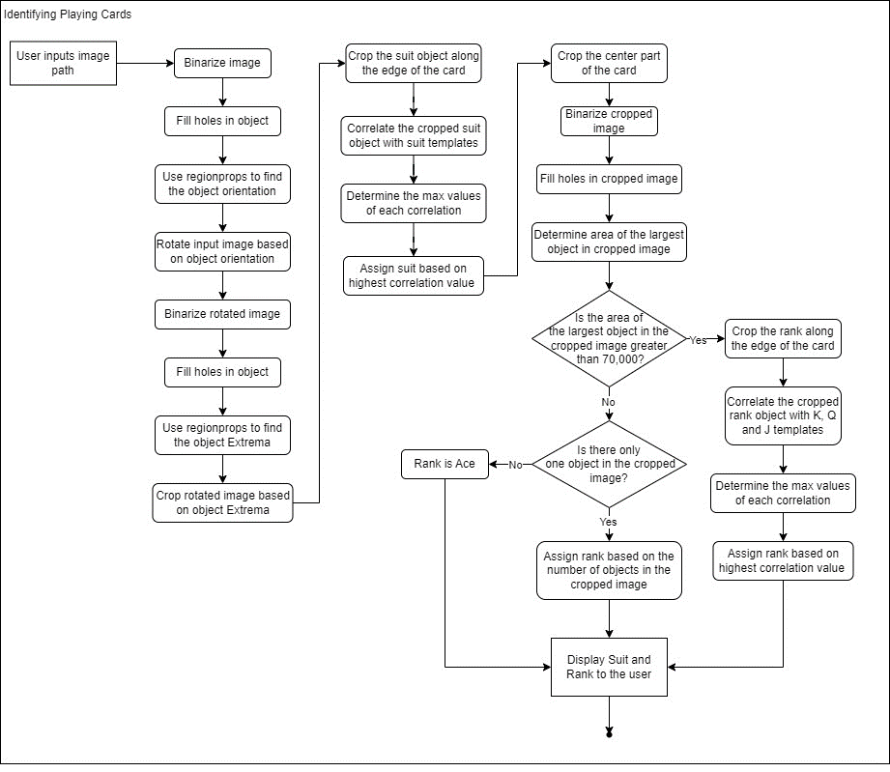

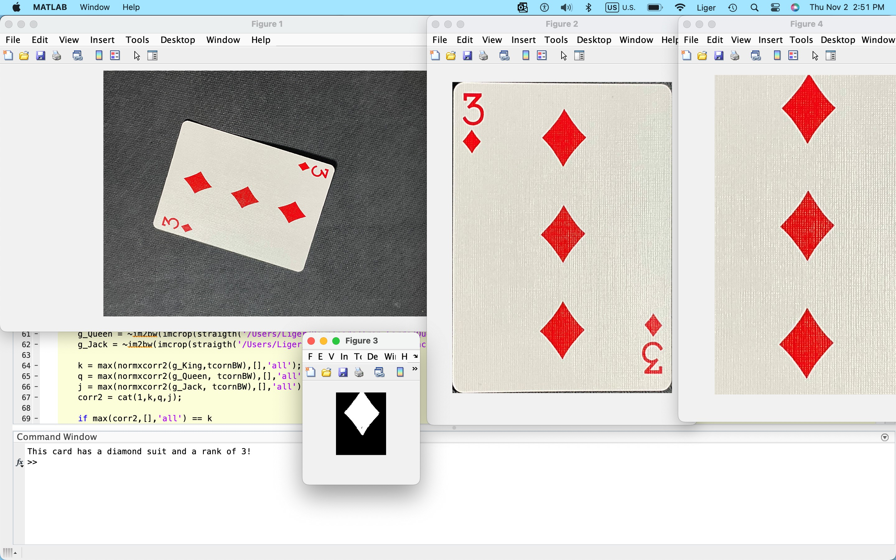Subset of results:

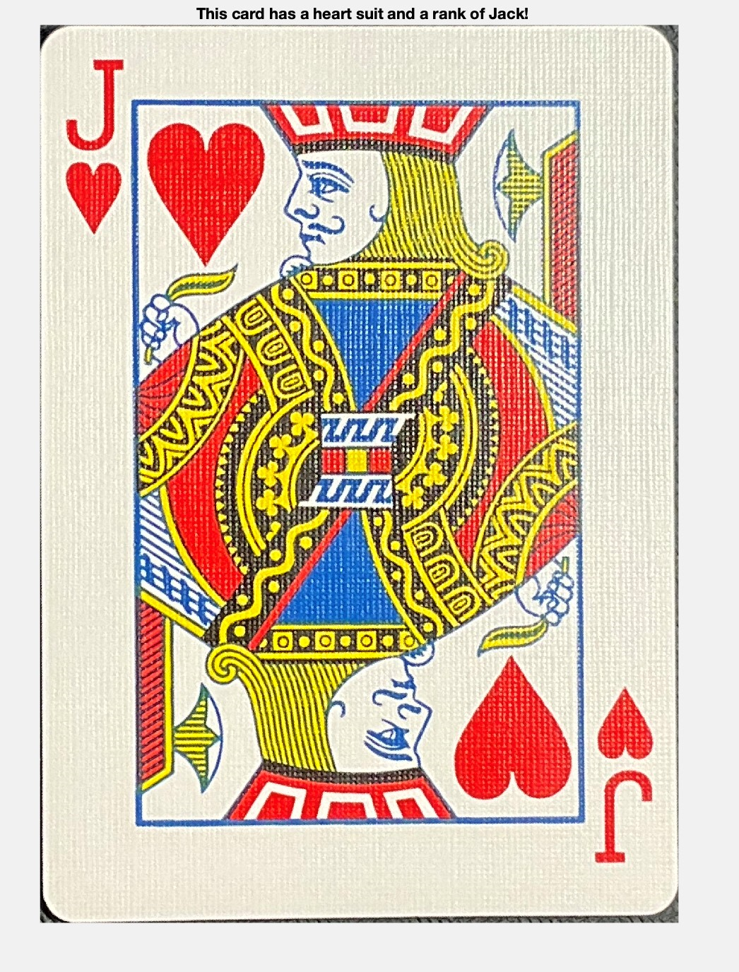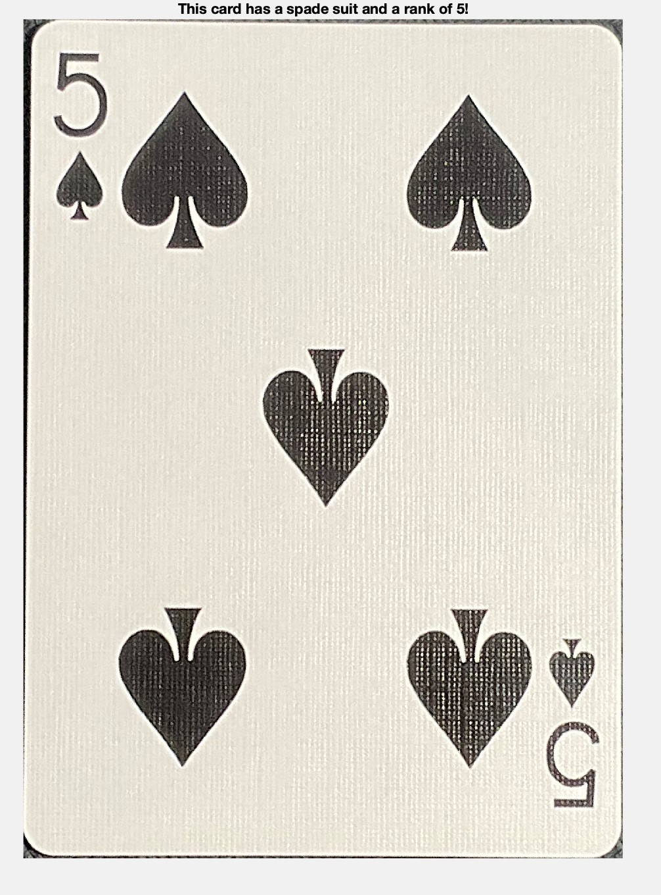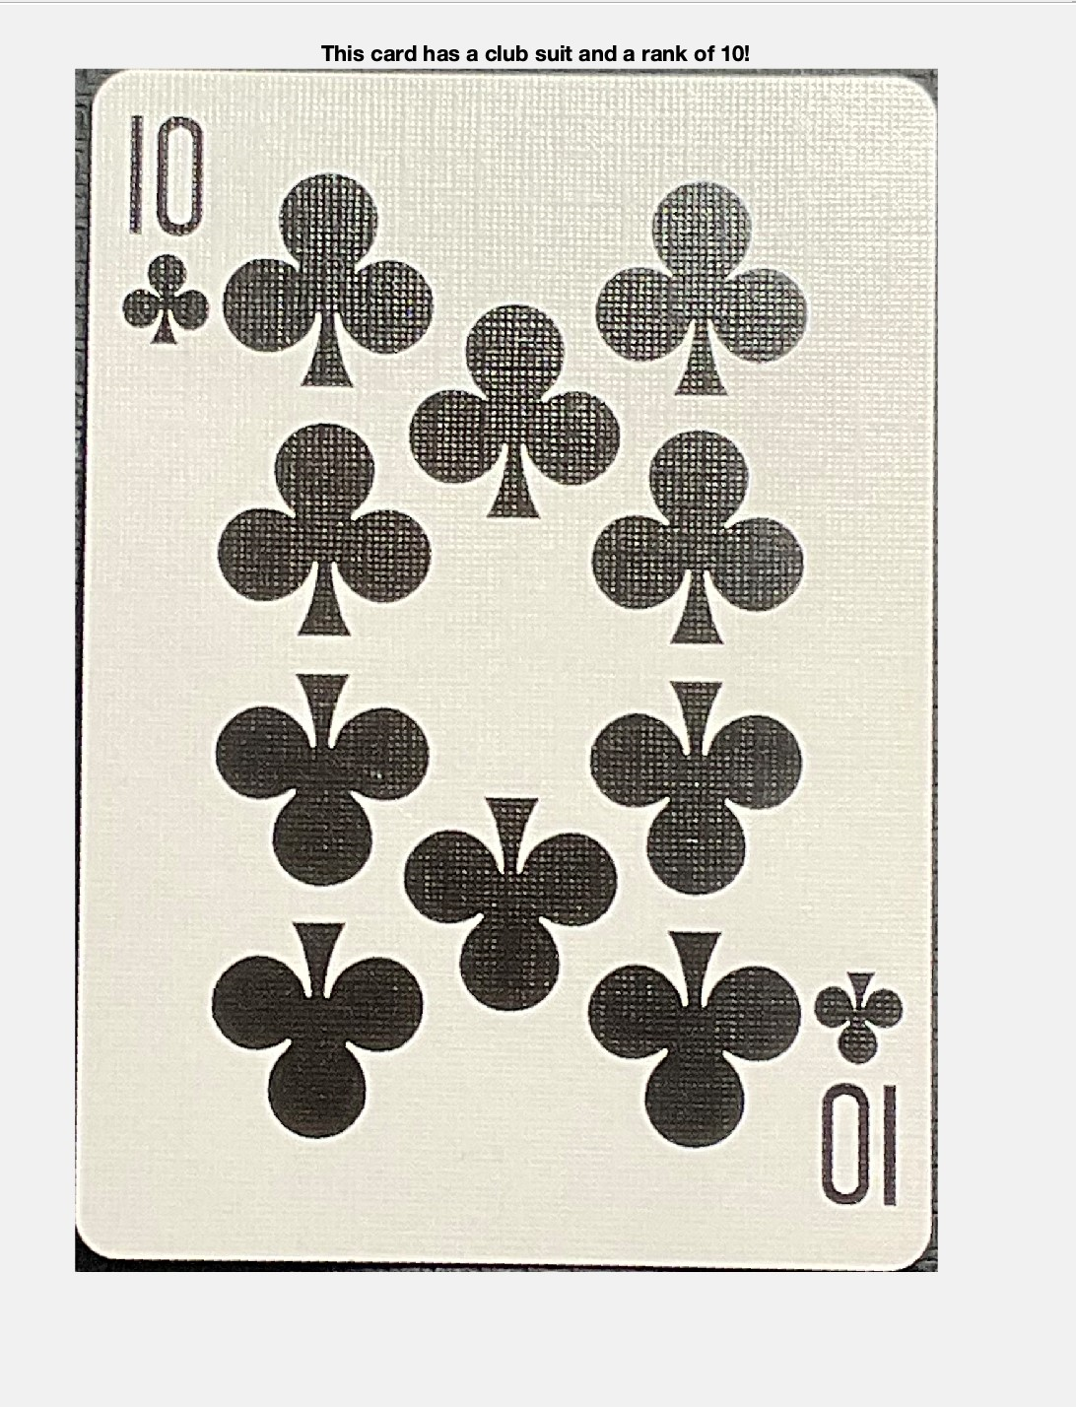

Description of contributions of each member:

* Whitney
  + Design Solution Algorithm
  + Write code
  + Test and Debug code
  + Create image taking set up
  + Narrate Video
* Megan
  + Design Solution Algorithm
  + Take pictures of the cards
  + Put together report
  + Make flowchart
  + Film Video

List of references:

* <https://www.mathworks.com/help/images/ref/regionprops.html>
* <https://www.mathworks.com/help/images/ref/normxcorr2.html>